**Authenticated Banking system**

**Outcomes of Projects**

**1-** To provide data security to the user using user profile technique and decoy

Technology.

**2-** Detection of masquerade activity by placing decoy technology in file system.

**3-** Track the attacker by its I.P address.

**1-** **To provide data security to the user using user profile technique and decoy**

**Technology.**

Home page

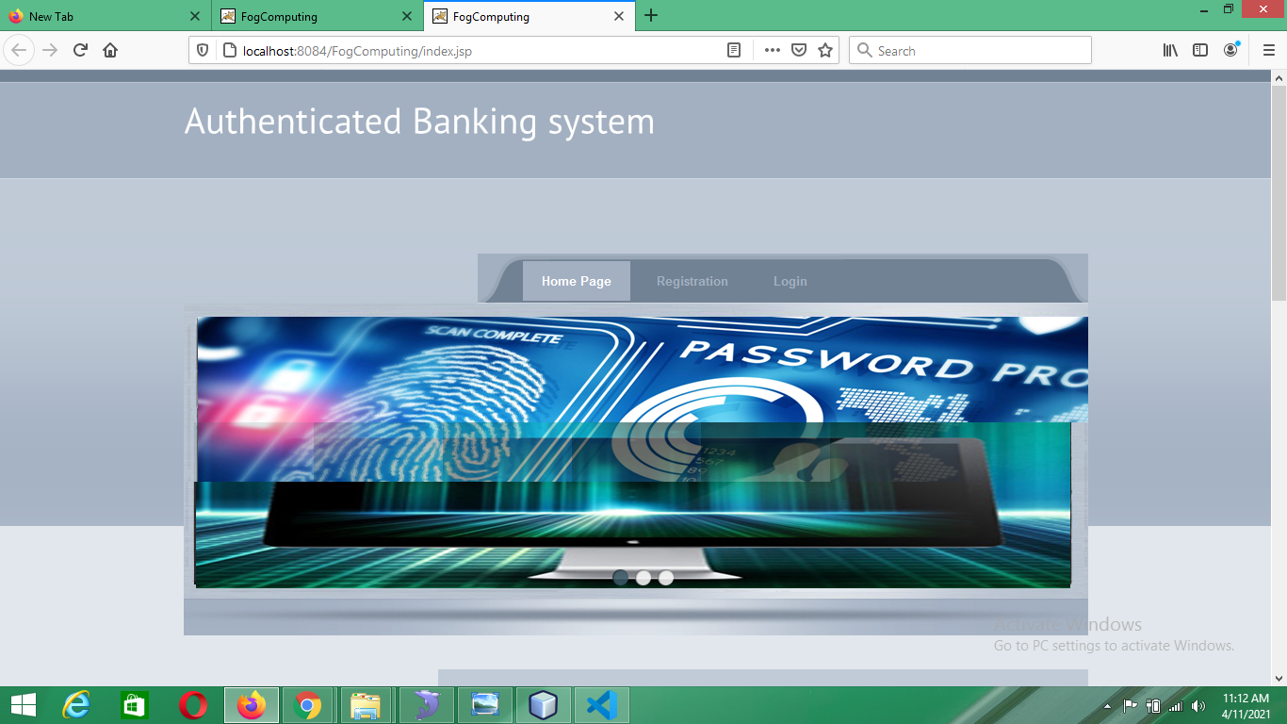

Fig 1.1

**User behavior Profiling**

Login page

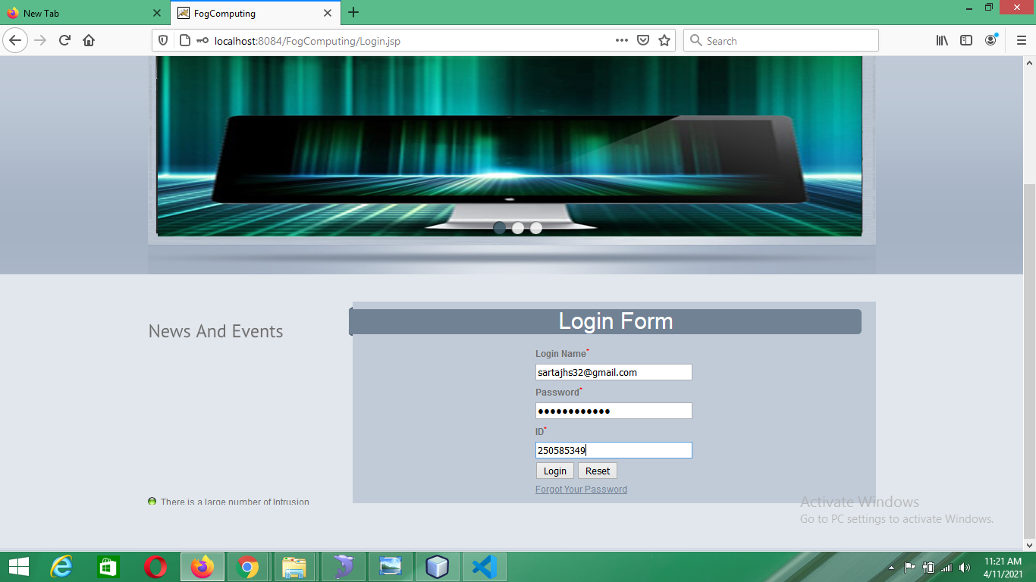

Fig. 1.2.1

Login page with captcha

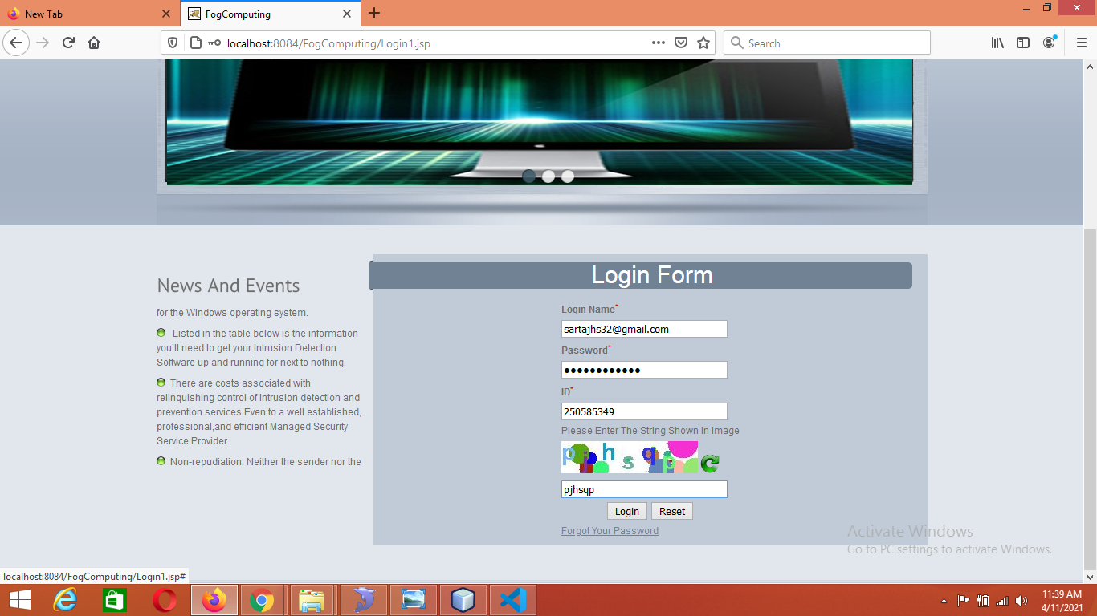

Fig. 1.2.2

Psychometric test

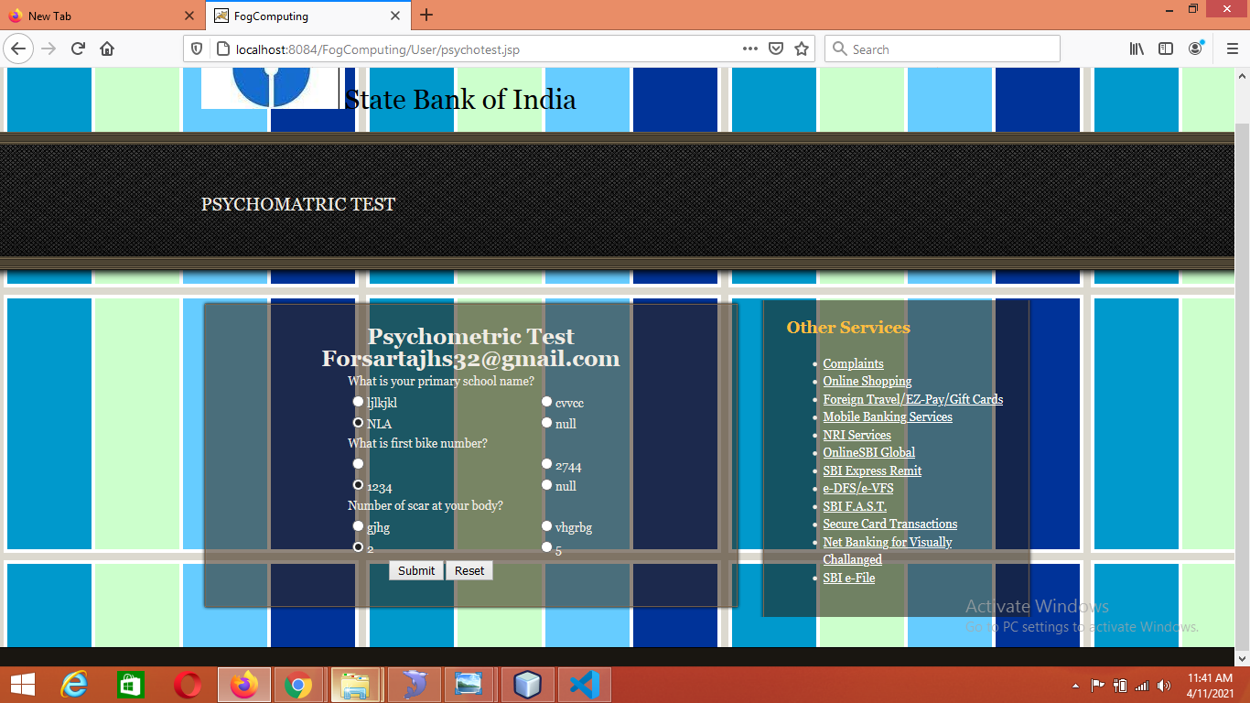

Fig 1.2.3

**Decoy Technology**

Authenticated user access original server

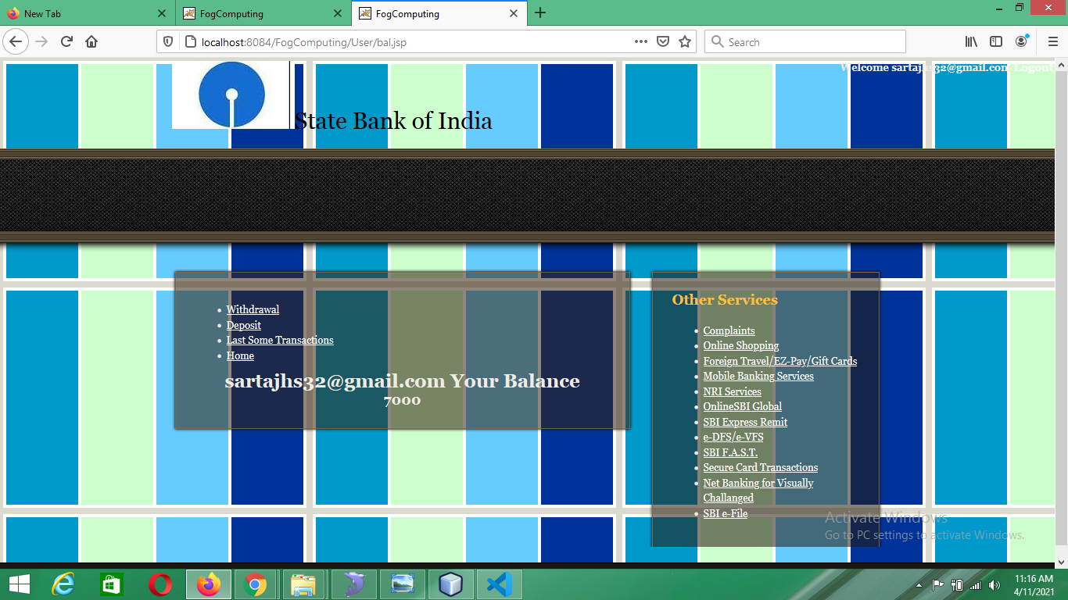

Fig 1.3.1

Unauthenticated user transfer to fake server

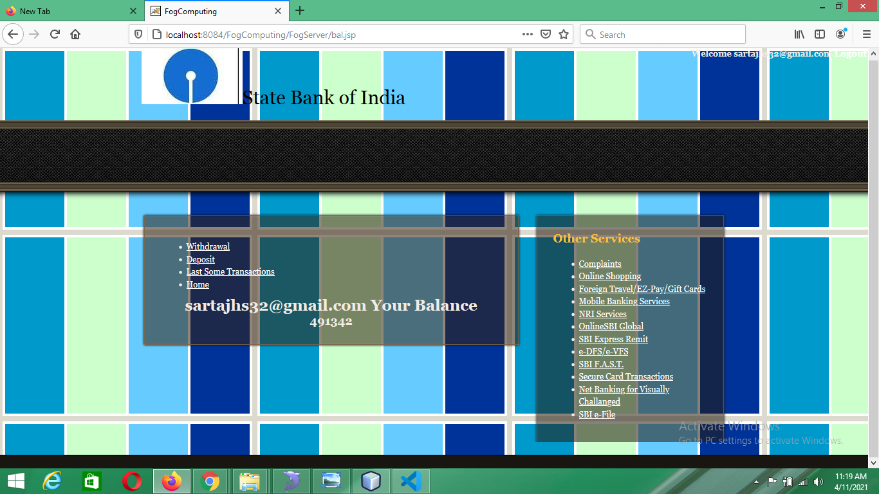

Fig 1.3.2

**2- Detection of masquerade activity by placing decoy technology in file system.**

System block to user to avoid integrity loss

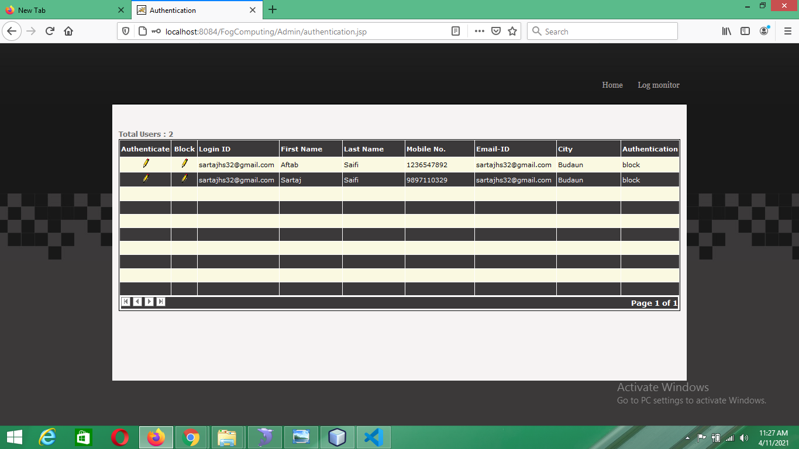

Fig 2.1

**3- Track the attacker by its I.P address.**

System send a alert mail to admin account with attacker I.P. address

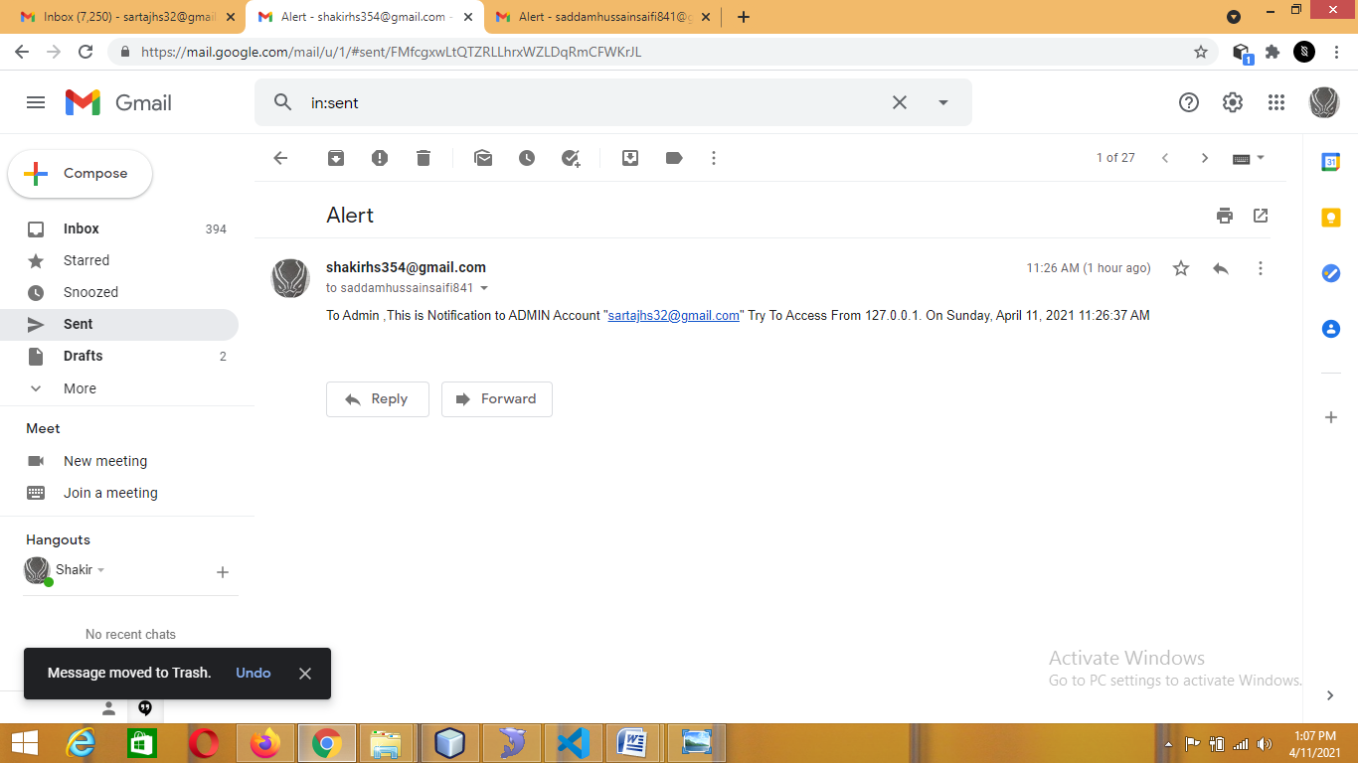

Fig 3.1

Admin received a alert mail from system with attacker I.P. address

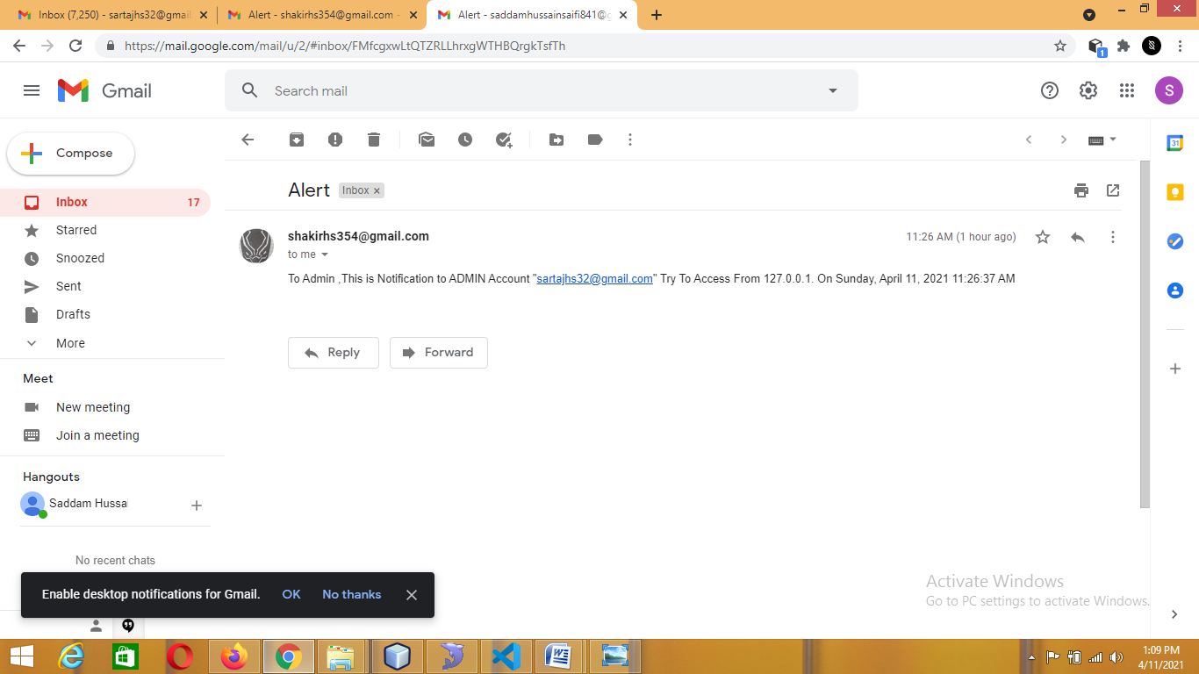

Fig 3.2